Frankenstein, ch. 18 – 19
Part I
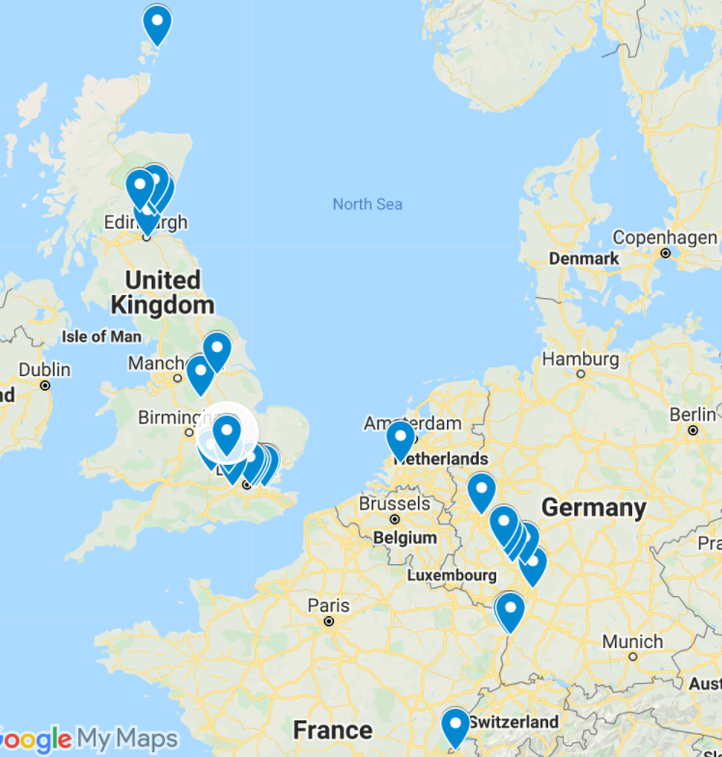
Visit the Google map that traces various spots along the route Victor takes from his home in Geneva, Switzerland to a remote island in the Orkneys (Scotland). Click on each location in the list on the left to see a photo (or sometimes multiple photos) as well as the reference to that location in the novel. You can also click on the blue location arrow to find more information and see additional photos of that location.
Part II
We’re going to take a tour with Victor. Click on the link to access the shared PowerPoint. Navigate to your slide and then do some research on your place’s significance. On your slide, add a photo of your place as well as some key information about your place. What is the place known for? Why is it significant as a place? Why would Shelley specify this place as a spot in Victor’s journey?
Part III
Jean-Jacques Rousseau
Many of the places Victor travels in ch. 18-19 were places Mary Shelley herself had visited in the months just before writing the novel. For example, she first started writing the novel while visiting Lord Byron in Geneva, Switzerland, where much of the novel takes place as it is Victor’s home. However, many of the places Victor visits also have historical significance. An influential philosopher, Jean-Jacques Rousseau was born in Geneva and his philosophy greatly impacted the Enlightenment, Romanticism, and Shelley herself. There are many parallels between Rousseau’s experiences and Victor’s. Visit the links below to learn more about Jean-Jacques Rousseau.
Political Theory – Jean-Jacques Rousseau – YouTube Video
Kids Philosophy Slam – Jean-Jacques Rousseau
Rousseau and Frankenstein

List 5 key facts about Rousseau and explain how these connect Rousseau to Frankenstein.
a.
b.
c.
d.
e.

