The Klondike/Yukon Gold Rush and Jack London
Part 1: Read through the information at the websites below, making note of the key information. Then answer the questions below.
The Klondike Gold Rush
Banking on the Stampeders – Dyea vs. Skagway
The Trails
- What event sparked the Klondike Gold Rush? How did the Klondike Gold Rush?

- How did various people attempt to cash in on the Gold Rush?

- What were the two main trails Klondikers took? What were the advantages and disadvantages of each?

- What obstacles did the Klondikers face? Describe several.

- How does the inclusion of the letter excerpts on the “Banking on the Stampeders” and “The Trails” pages impact your understanding of the events described?

Part 2: Click on the links below to look at photographs related to the Klondike Gold Rush. Then respond to the questions below.
Front Street during winter, Dawson, Yukon Territory, ca. 1899
Chilkoot Trail from Stone House, Alaska, 1898
Klondikers Ascending to Summit of Chilkoot Pass
“The Golden Stairs”
Two Men at the Summit of White Pass
Thermometer Registering 68° below Zero
Dog Sled with Supplies, Chilkoot Trail
Horse Drawn Sleds, White Pass
Men Crossing Ice Bridge
Rescue Attempt from a Crevice
Rescuing a Man Fallen through the Ice

- Which two photos did you find most compelling/engaging? Explain why.

- Select one of the photos above and imagine you witnessed the scene first-hand. Like the excerpts of the letters from the pages in Part 1, compose a short account of your experience. This could take the form of a letter or diary/journal entry.

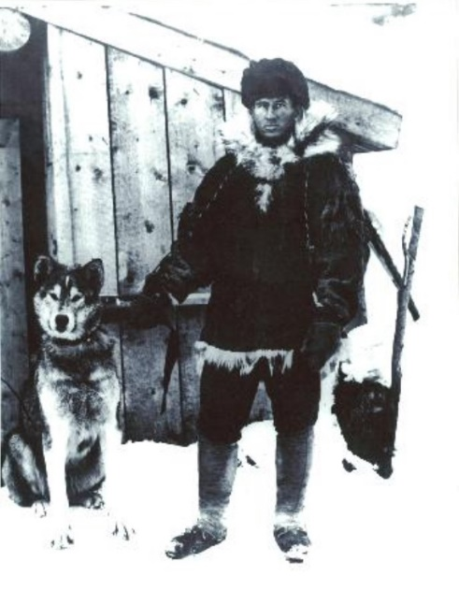
Part 3: Click on the links below to learn about American naturalist writer Jack London and his connection with the Klondike Gold Rush. Then respond to the questions below.
The Literature of the Gold Rush
GOLD FEVER! DEADLY COLD! & THE AMAZING TRUE ADVENTURES OF JACK LONDON IN THE WILD

- How might London’s experiences in the Yukon be described as both a failure and a success?

- List at least 5 specific details the “Gold Fever” article provides about Jack London.

- List at least 3 specific examples of how Jack London’s experiences in the Yukon were used in his different writings.

