The Great Gatsby – ch. 4
There are 4 main sections of ch. 4, and we will look most closely at the last 3.
Section 1 – List of Partygoers
In the first section, Nick includes a long list of people who attend Gatsby’s parties throughout the summer. Many of the names sound like animal names, which may suggest the animalistic nature of humans (e.g., Leeches, Civet, Blackbuck, Beaver, Fishguards, Whitebait, Hammerhead, Beluga...). Additionally, Nick reports some “unhappy” news related to several of the people listed. For example, “Snell was there three days before he went to the penitentiary, so drunk out on the gravel drive that Mrs. Ulysses Swett’s automobile ran over his right hand.” and “And the Catlips and the Bembergs and G. Earl Muldoon, brother to that Muldoon who afterward strangled his wife.” In addition to some negative details, Nick shows that anyone and everyone (from senators to gangsters) came to Gatsby’s parties.
**From this first section, we need to remember only one person as an individual: “A man named Klipspringer was there so often and so long that he became known as ‘the boarder’—I doubt if he had any other home.” Klipspringer is mentioned here, and we’ll see him again in ch. 5 and ch. 9. The point here is that the guy is a freeloader; he comes to one of Gatsby’s parties and never leaves. He just kind of moves in. So while many guests take advantage of Gatsby’s hospitality, this guy takes it to a whole new level.
Section 2 – Gatsby and Nick’s Drive into the City for Lunch
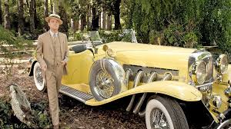
Up to this point, Gatsby has been somewhat shrouded in mystery. In this section, Nick gets to know Gatsby a bit more. However, there is still a sense of confusion about who Gatsby actually is and what his purposes are. Consequently, Nick is unsure of how to feel about Gatsby. In parts of the conversation he has more positive feelings toward him and in other parts he doesn’t like him at all. In the boxes below, list details from this section of the book that fit in each quadrant. For example, if a detail seems realistic/true and Nick responds or feels positively, place that detail in quadrant 4. If a detail seems unrealistic and Nick feels negatively about it (e.g., annoyed, disgusted, confused), place it in quadrant 3.

Unrealistic & Nick feels | Realistic & Nick feels Positive
Unrealistic & Nick feels | Realistic & Nick feels

- What do these details suggest about Gatsby? What do they suggest about Nick?

Section 3 – Lunch with Meyer Wolfsheim
In this section we meet a friend/business associate of Gatsby’s named Meyer Wolfsheim, who is based upon an actual person named Arnold Rothstein, a 1920's gangster/gambler. Read about Rothstein at the link provided and answer the two questions below.
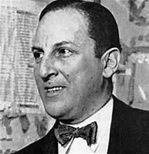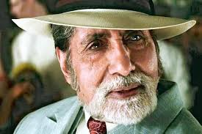
- What was Rothstein's nickname?

- How much money is Rothstein said to have made from fixing the 1919 World Series?

In ch. 4, how is Wolfsheim characterized? Fill out the chart below with details about Wolfsheim’s characterization reflected in his physical appearance, in what he says, and in what others (mostly Gatsby) say about him. (specific things to note: how Wolfsheim feels about where they’re eating in comparison to the Old Metropole, his story about Rosy Rosenthal, his cuff links, what he says when he leaves, etc.)

Meyer Wolfsheim |  | Inferences
Physical descriptions
What he says
What others say about him

- At the end of the lunch, Nick sees Tom and goes over to talk to him. How does Gatsby react/behave in this part?

Section 4 – Jordan’s Conversation with Nick (Daisy’s past and Gatsby’s Request)
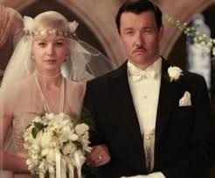
In this section, Jordan explains events over the course of about 5 years (1917-1922). Fitzgerald uses Jordan to give us a glimpse into Daisy’s past – her relationship with Tom and her relationship with Gatsby. In the chart below, list in chronological order six events revealed in this conversation and then comment on the significance of each event.
Event/Detail | Significance

