1920s Webquest
Welcome to the world of the 1920s! To more fully understand the context of The Great Gatsby, visit the following websites and complete the questions on your own paper. Label each section clearly.
I. Organized Crime
As a guest at Gatsby's party, you've probably heard the rumors. He killed a man. He was a German spy during the Great War. He was educated at Oxford. He has a lot of money, and serves great food and champagne at his parties. And, of course, he's probably involved in organized crime.
A. Read about Al Capone, America's most notorious gangster and leader of organized crime in the 1920s:
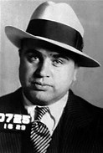
1. What was Capone's nickname and how did he get it?
2. When Capone moved to Chicago and became the protege of Torrio, how did he eventually become the head of Torrio's businesses? How much did Capone's operations earn annually?
3. What was the St. Valentine's Day Massacre?
4. How did Capone help people after the 1929 stock market crash?
5. Despite the extent of his crimes, it was difficult for police to ever connect Capone with them. How did authorities finally convict Capone, and what did he serve prison time for?
6. What was the name of the second prison Capone was sent to?
7. When and how did Capone die?

- Read about Arnold Rothstein, a 1920's gangster who served as inspiration for one of the characters in The Great Gatsby.
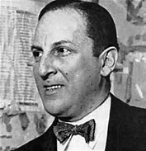
- What was Rothstein's nickname?

- How much money is Rothstein said to have made from fixing the 1919 World Series?

II. The Black Sox: The 1919 World Series Scandal
The 1920s saw scandal and corruption infiltrate even the most American of pastimes: baseball.
1919 "Black Sox" Scandal
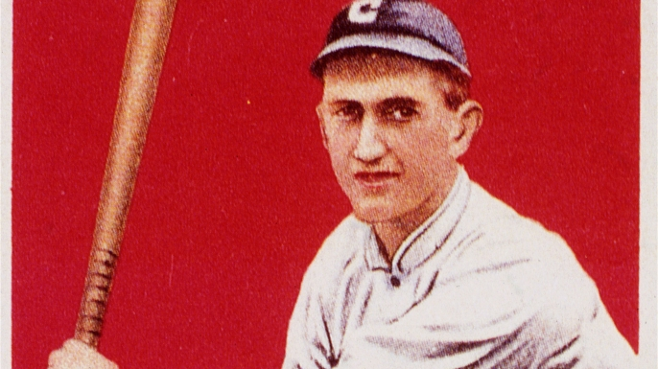
1. What were 8 of the Chicago White Sox accused of doing?
2. Although never convicted, who is thought to have been a major player in funding the scandal?
3. Why did some of the players decide to call off the deal a few games into the series?
4. What led to an investigation of the scandal in 1920? What led to an acquittal?
5. Despite the acquittal, what action did baseball's commissioner take?
III. An Overview of the 1920s

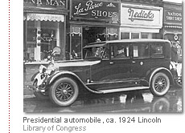
Click on the above link and read through the pages to get an overview of the 1920s. At the bottom of each section, click “Roar” or “Yawn” to advance to the next page; it doesn’t matter which you select.
- "Introduction": What was the nickname of the 1920s? What were some of the events that occurred during this decade?
- "Economic Prosperity": What were people spending their money on? On the other hand, what businesses and workers had more difficulty?
- "The Effects of Prohibition": How did people get alcohol illegally? Did the consumption of alcohol decrease under Prohibition?
  - Take a look at these photos of speakeasies.
- "The Impact of Popular Culture": Who were the stars (male and female) idolized by Americans? What were some of the things young people did for fun?
- "The Effects of the Automobile": How did the mass production of the automobile change America?
    - Check out these pictures of 1920s automobiles.
    - This picture is similar to Gatsby's car in The Great Gatsby:

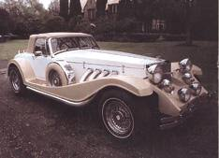

- Fashion
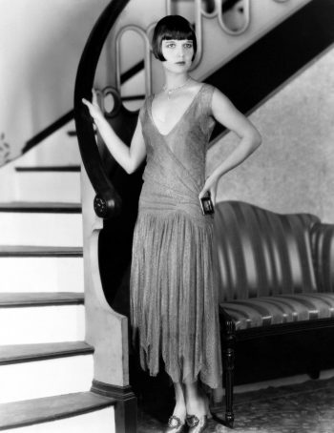
Check out 1920's fashion by browsing various websites below:
Jazz Babies (You will need to click on the image and then select from the drop-down menu to see different styles.)
Vintage Dancer
Victoriana Magazine
The Costume Gallery
Louise Brooks (an American film actress and dancer and one of the 1920s most famous flappers)
- Describe some of the changes in fashion that occurred in the 1920s.
- Read Dorothy Parker's poem "The Flapper." What is Parker's feeling toward flappers? Why?
- Sketch an outfit for a man or woman.

V. 1920's Slang
You’d want to fit in at one of Gatsby’s parties to be able to talk to everyone and try to impress the elusive Mr. Gatsby, as well as the East Eggers!
Check out the following websites of 1920's slang:
Slang of the 1920s
Twenties Slang
- Rewrite this 1920's letter, substituting modern usage for the 1920s slang.
Dear sister,
How are you doing? I am very copacetic. I met a hard-boiled man named Henry last week. I carry a torch for him. He is a Fly Boy with some real jack, and NO, I am not being a gold digger. He likes me for me and not my flapper look. He told me I’m a doll, and I know he wasn’t just giving me a line. He isn’t a lounge lizard. He understands me when I tell him the bank is closed!! I mean, I’m not a quiff, after all. Also, he doesn’t hang out at gin mills and get ossified. He’s a swell and swanky man.
After George was bumped off, I never thought that I would be able to middle aisle again. I’ve gone out with a few dates with fellas who turned out to be bluenoses, gimlets, or dead hoofers. I’m telling you, they were real flat tires. I did go on a blind date with a fella my friend said was the big cheese somewhere, a real sheik. He was keen, but he took me to a juice joint, got blotto, and then upchucked all over my glad rags. Di Mi!
But Henry is the bee’s knees, the berries, and he’s never been in trouble with the Bulls. He’s an egg that drives a breezer; he’s no piker, trust me. I guess I am just stuck on him! What a tomato I’m being. He’s my daddy and I am his dame. I promise I won’t take any wood nickels to ruin this relationship. He is a hoofer, a very hotsy totsy hoofer. He’s no rag-amuffin like George, always spillflicated and taking hairs of dogs! I just need to get a wiggle on with my life. Wish me luck! Well, I must be going dear. See you in the summer.
Sincerely,
Margaret

<<1920s slang letter.pdf>>

- Compose a conversation between two people about anything you've read about the 1920s and use at least 10 slang terms. Underline the slang terms you include.

  - Great Gatsby Trailers
Watch the trailers for the various Great Gatsby films and write a short reflection about them. Some questions that you might consider, but that you are not limited to, include: What stands out to you? What overall impression does each give? What differences do you see? Based upon the trailers, what expectations do you have for the novel?
  - 1926
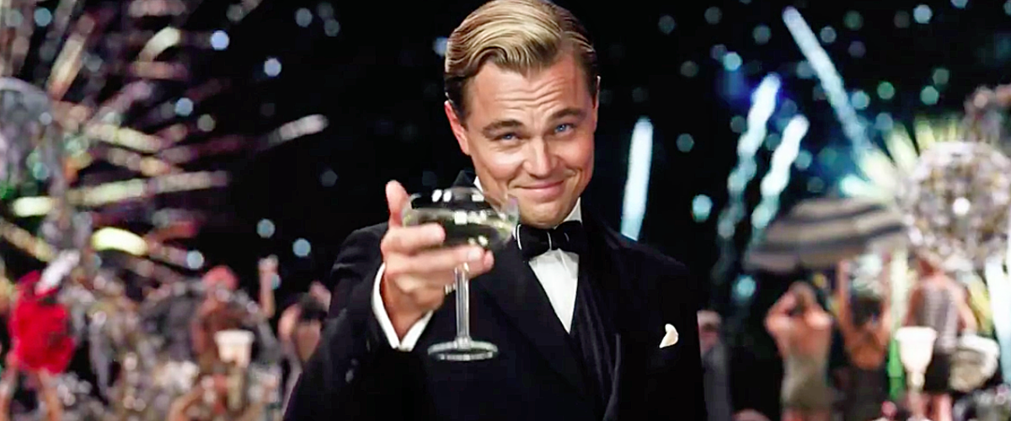
  - 1974
  - 2013

